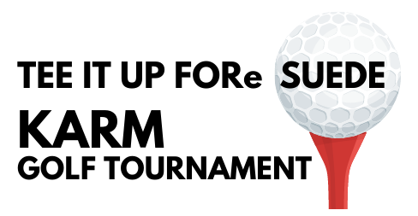
2023 Sponsorship Opportunities
Monday, September 25
8am Morning Flight/2pm Afternoon Flight
Avalon Golf & Country Club
www.KARM.org/golf

Presenting Sponsor $10,000
- Eight player entries
- Company logo listed as Presenting Sponsor on all marketing pieces, printed/email invitations, event webpage with link to company’s website
- Company mentioned in all media promotions both radio and television as presenting sponsor
- Company logo printed on (2) Hole Flags to be displayed on front and back nine
- Company logo on all event signage including tee box, driving range, and auction area
- Company logo recognition on THREE pre- and/or post-event social media posts
- Company may provide promotional items for golfers at event prize tables or a select hole of your choice. (KARM can provide volunteers if requested.)
- TWO free foursomes at Avalon Golf & Country Club (certificates for 1 year)
Premier Sponsor $5,000
- Four player entries
- Company logo listed as Tournament Hole Sponsor on all marketing pieces, printed/email invitations, event webpage with link to company’s website
- Company mentioned in all media promotions both radio and television
- Company logo printed on (2) Hole Flags to be displayed on front and back nine
- Company logo recognition on official event signage including tee box and auction area
- Company may provide give-a-ways at a select hole during morning and/or afternoon sessions (KARM can provide volunteers if requested.)
Tournament Ball Sponsor $2,500
- Four player entries
- Company logo printed on golf balls provided to all players
- Company logo listed on all marketing pieces including webpage with link to company’s website
- Company logo recognition on official event signage including tee box and auction area
- Company may provide give-a-ways at a select hole during morning and/or afternoon sessions (KARM can provide volunteers if requested.)
Front Nine / Back Nine Sponsor $1,500
- Four player entries
- Company logo listed on all marketing pieces including event webpage
- Company logo recognized as Front Nine and Back Nine Sponsor on 1st and 10th holes
- Company may provide give-a-ways at a select hole during morning and/or afternoon sessions (KARM can provide volunteers if needed.)
-over-
Tournament Cart Sponsor $1,000
- Four player entries
- Company logo displayed on all tournament golf carts
- Company logo recognition on official event signage including tee box and auction area
Driving Range Sponsor $1,000
- Four player entries
- Company logo displayed on signage at driving range
- Company logo recognition on official event signage including tee box and auction area
Foursome $600
- Four player entries
- Players receive one sleeve of tournament golf balls and a tournament gift
- Greens fees, art, range balls snacks and lunch/dinner
Beverage Cart Sponsor $500
- Company logo on roaming two beverage carts
- Company logo displayed on event signage at registration
Tee Box Sponsor $250
- Sponsor logo displayed on a tee box sign
Individual Player $150
- Players receive one sleeve of tournament golf balls and a tournament gift
- Greens fees, art, range balls snacks and lunch/dinner

